MTH481/581 - INFORMATION ABOUT THE FINAL

The final exam is scheduled for Wednesday, December 14, 8:00AM-10:00AM, in our regular classroom. The final exam is closed-books. A scientific calculator can be used.
In preparation for the final carefully review exams 1, 2 and 3, and all homework assignments.

Your final exam score will replace your lowest score out of our three midterms if the former exceeds the latter.

Sections from the textbook covered in the exam
8.1/8.2/8.3/9.1/9.2/9.3/9.5/9.6/10.1—10.8/11.1/11.4/11.5

MTH481/581 Review problems

- Verify by substitution that 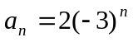 is a solution of the recurrence relation 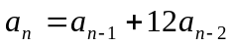.
- Give a recursive definition for your salary after n years, if you earn $30,000 now and each year you receive a 3% raise on your current salary, plus an increase of $400.
- Find a formula for the solution of the recurrence relation 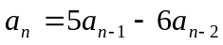 with initial conditions 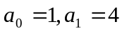.
- Find a formula for the solution of the recurrence relation 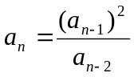.
- Find a formula for the solution of the recurrence relation 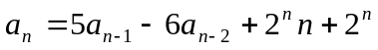.
- Determine whether the graph with adjacency matrix 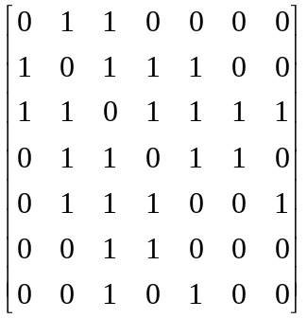 has an Euler circuit; Euler path; Hamiltonian circuit; Hamiltonian path.
- For each of the following, either find a graph with that property or prove that none exists.
  - A graph with 4 vertices that is not planar.
  - A simple graph with degrees 1,1,2,2,3.
  - A graph with 5 vertices with an Euler circuit but no Hamiltonian circuit.
  - A simple planar graph with 7 vertices, 9 edges, and 5 regions.
- Suppose G is a simple graph with 9 vertices. Prove that G must have at least two vertices with the same degree.
- Let G denote a graph with n nodes and m edges. Let M be the largest degree of the vertices of G. Prove that 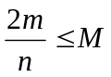.
- Prove that any tree has at least two vertices of degree 1.
- Give a formula for the number of edges in 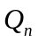. Prove your answer is correct.
- Prove that the graph 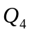 is not planar.
- What is the chromatic number of 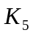? 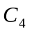? 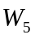? 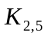?
- Determine whether the following relations are reflexive, symmetric, anti-symmetric, and/or transitive.
  - 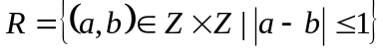.
  - 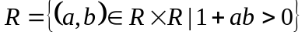.
  - Is any of the above relations a partial order? An equivalence relation?
- Show that the relation R where bit strings (0-1 strings) are related if and only if they contain the same number of 0s is an equivalence relation. What are the equivalence classes of the bit strings 1, 00, and 101 under the relation R?
- Show that the inclusion relation 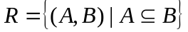 is a partial order on the sets of all subsets of Z.
- What are the minimal and maximal elements in the poset with the following Hasse diagram? Are there greatest and least elements? What is the greatest lower bound of the set 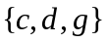? What is the least upper bound of the set ? What is the greatest lower bound of the set 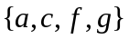? What is the least upper bound of the set ?

